- worksheet к песне
Let is snow+квизлет и вордволл
https://quizlet.com/_96egzg?x=1jqt&i=q07i0
https://wordwall.net/ru/resource/8435755
Let it Snow .pdf

- Mog's Christmas Calamity – видео and worksheets
https://yandex.ru/video/preview/?text=mog%27s+christmas+calamity+worksheets&path=wizard&parent-reqid=1608055439860034-647985223329898851900107-production-app-host-vla-web-yp-97&wiz_type=vital&filmId=13444339098693554936&url=http%3A%2F%2Fwww.youtube.com%2Fwatch%3Fv%3DB548zliRJ8U
https://en.islcollective.com/english-esl-worksheets/grammar/wh-questions-and-open-ended-questions/mogs-christmas-calamity/103326
mogs-christmas-video_teacher_switcher.docx
mogs-christmas-calamity_teacher_switcher.docx
mog_teacher_switcher.doc
christmas-dishes-from-around-the-world_teacher_switcher.doc
how-to-celebrate-christmas_teacher_switcher.docx
origins-of-christmas_teacher_switcher.docx
christmas-symbols_teacher_switcher.docx

Угадай-ки

- https://www.youtube.com/watch?v=1YypzFH_lXU&feature=emb_logo
- https://www.youtube.com/watch?v=YYAxTzD-N0I&feature=emb_logo
- https://www.youtube.com/watch?v=F3BR3XDyhXc&feature=emb_logo
- https://www.youtube.com/watch?v=p_EUtiDZglg&feature=emb_logo
- https://www.youtube.com/watch?v=oQu4QyFZijc&feature=emb_logo
- https://www.youtube.com/watch?v=fU55ZwuKo1w&feature=emb_logo
- https://www.youtube.com/watch?v=GcJoIlaXNV8&feature=emb_logo
CHRISTMAS FLASHCARDS!
- christmas-flashcards-set-1-from-freeflashcardsdown-flashcards-fun-activities-games_120547.docx
- sss-christmas-complete-flashcards.pdf
- TEFL+Lemon+Christmas+Flashcards+for+ESL+Classes.pdf
- christmas-flashcards-flashcards-games_36747.docx
- Christmas-Set.pdf
https://www.youtube.com/watch?v=Nwz6IC4WzMg&feature=emb_logo
https://www.youtube.com/watch?v=q1b7cBvGLjM&feature=emb_logo
https://www.youtube.com/watch?v=Kg__vXsU8xw&feature=emb_logo
https://www.youtube.com/watch?v=0rkP-R240Ys&feature=emb_logo
Конспекты к Рождеству
https://mishkie.ru/full-year
Письмо от Санты _ by Artem Morozov.pdf
Письмо от Санты _ simple _ by Artem Morozov.pdf
Письмо Санте _ by Artem Morozov.pdf
Письма Санте _ simple _ by Artem Morozov.pdf

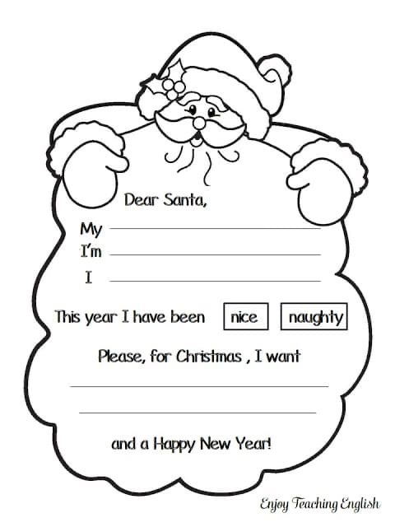

РАБОЧИЕ ЛИСТЫ ПО РОЖДЕСТВЕНСКИМ ПЕСНЯМ
all-i-want-for-christmas_teacher_switcher.docx
all-i-want-for-christmas-worksheet_teacher_switcher.pdf
coldplay-christmas lights_teacher_switcher.pdf
jingle-bells_teacher_switcher.doc
last-christmas_teacher_switcher.doc
let-it-snow_teacher_switcher.doc
mistletoe-justin-bieber_teacher_switcher.pdf
train-shakeup-xmas_teacher_switcher.doc
twas-the-night-before-christmas_teacher_switcher.docx

рождественский рекламный ролик и рабочий лист (для младших школьников) к нему
SuperValu Christmas Advert 2020 connor's christmas worksheet.pdf

Santa worksheets

christmas-grammar-worksheet.pdf
christmas-worksheet-for-children.pdf
santa-counting-worksheet.pdf
christmas-classification-worksheet.pdf
christmas-tree-coloring-worksheet.pdf

These are some of the most emotionally engaging Christmas ads of 2020 (so far):
- Kohl: Give With All Your Heart
“This year looks different – and so do our wish lists. Where once we just wished for things like toys and tech, we’re now wishing for happiness, understanding and kindness more than ever. And time spent together is the greatest gift of all. This year looks different because the world is different. So give with all your heart.”
https://www.youtube.com/watch?v=rqlgWXgOa_c&feature=emb_logo
2. Etsy: Gift Like You Mean It: Nana
“The perfect present goes the distance, even when you can’t. Find the right gift for the right one.”
https://www.youtube.com/watch?v=4o4eMcIe4NA&feature=emb_logo
3. Macy: In Dad’s Shoes
“A daughter takes an unexpected journey in finding the perfect gift for her dad this holiday season. The lesson in the end? This year, the real gift is the thought you put into it.”
https://www.youtube.com/watch?v=sC2JFpmQOrM&feature=emb_logo
4. Amazon: The Show Must Go On
“This is the story of a young dancer whose spirit and tenacity triumphs through the challenges of 2020. All with a little help from her family and community.”
https://www.youtube.com/watch?v=gQdLD6kk960&feature=emb_logo

